The set I have chosen for validation is 12.011, 207, 118, w, hydrogen, and Xe. The numbers show how the program will search with float or int input to still differentiate the numbers. The convertType function sets the initial input to a type based off how it was entered.

Floats and integers. Most the time the atomic mass is expressed with a decimal point, so usually that is what it looks for, but leads mass does not have numbers after the decimal point. Luckily its the only one, so I set the condition to include numbers higher than 118 to be included in the float conversion. If it does not see the ‘.’ it designates it as an integer.

12.011:

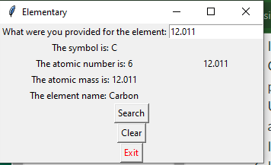

207:

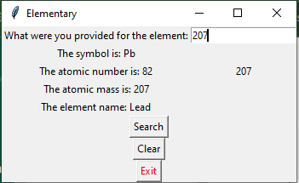

118:

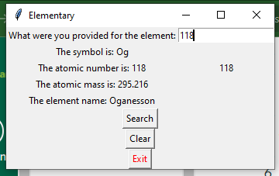

Symbols and Names: For ease of entry, any string entry is capitalized. Most the time people will do this with the symbol, as it is usually represented by a capital letter. The program differentiates by the length of the string. No symbol representation is longer than 2 characters, and no element name is less than 3.

xe:

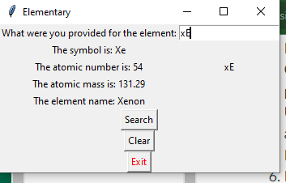

hydrogen:

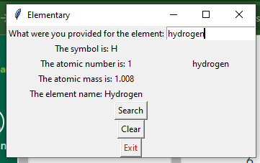

w:

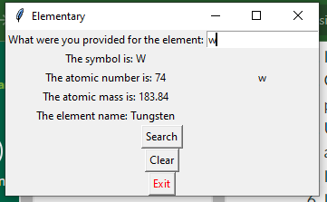

I initially had no way to search for 207 and get Lead. The .isdigit() function was missing from my comparison. After making my dictionary I had capitalized all the element symbols, but forgotten to do so with the names, so I had to cycle back through and capitalize every first letter of every element in the dictionary. I really struggled getting any results to show up. On my skeleton terminal model I had a while loop going through the list and printing all the designations. When I was converting everything to a function for the GUI version, I could not get the variables declared right to make the while loop work in the function with my GUI. Took most my time trying to figure out were my disconnect was. Ended up changing the dictionary {} to [] for each item listing. This allowed me to print more ordered instead of having to organize everything with a while loop. At first the while loop was necessary to organize the randomly arranged values in the dictionary.